- Introduction to Bash

Write a simple Bash shell script to display the message "Welcome to Bash learning" and "*****" on separate lines.
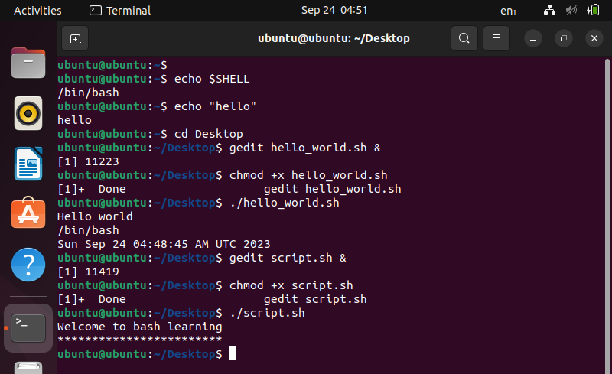

- Basics of Shell Scripting
Write a simple Bash program to get the following system variables:
a. pwd
b. logname
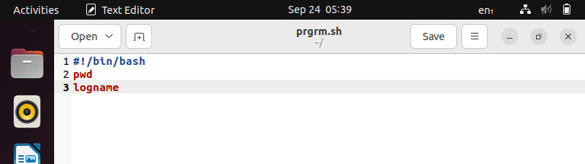
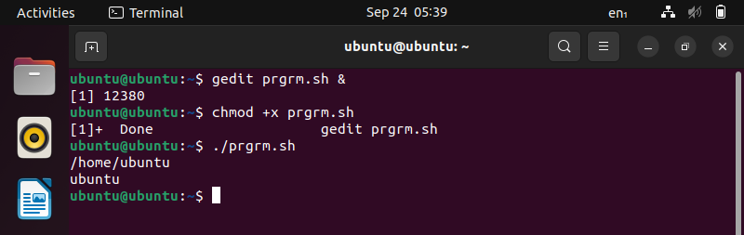
Write a simple Bash program:
a. To ask username from user
b. Exit the program, if user does not enter anything within 10 seconds
Hint: read -t 10 –p
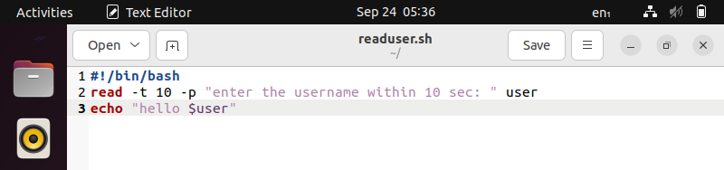
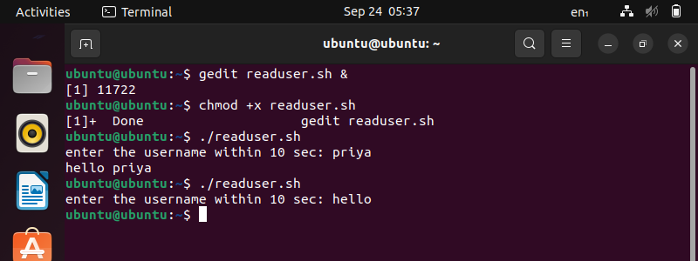

- Write a bash program for addition using command line arguments.
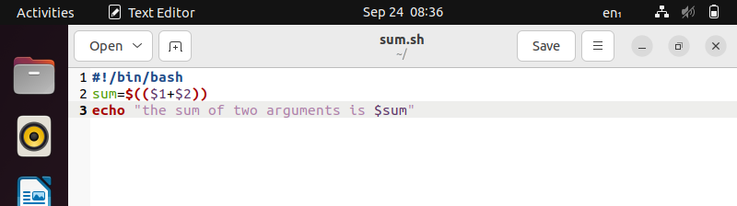
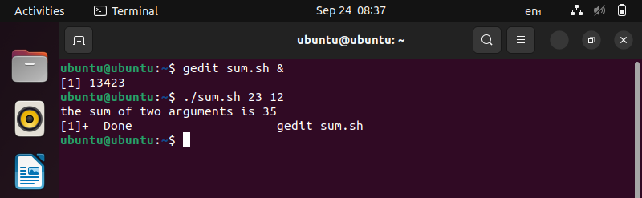

- Globbing and Export statement

- Write a Bash script to do all operations discussed under Globbing
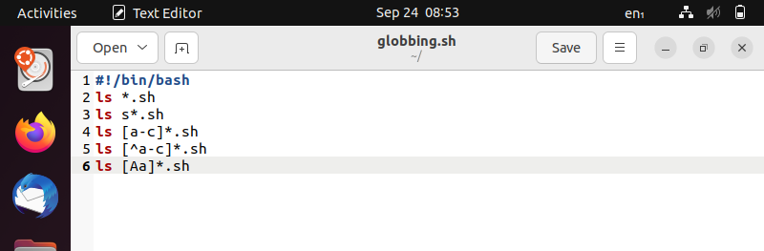
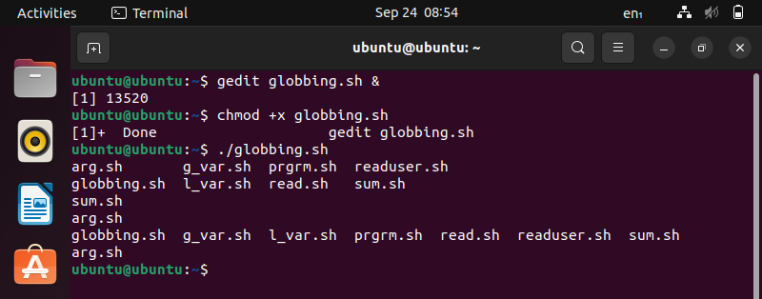

- Array Operations in BASH
Declare an Array names of length 7 and find
a. The total number of elements
b. Print all the elements
c. Print the 5th element
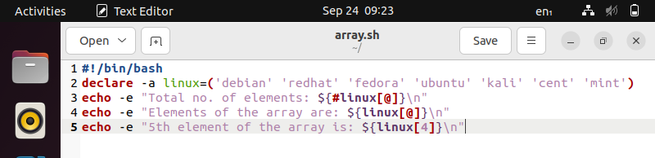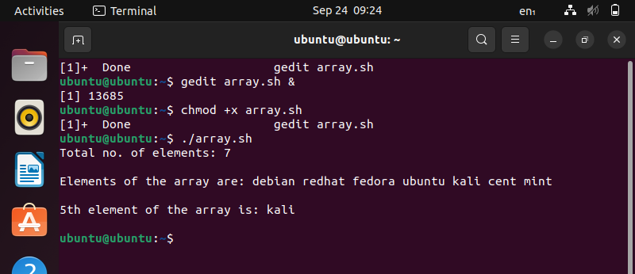
- More on arrays
Declare an Array names2 of length 7 and perform following operations-
a. Extract three elements starting from index two.
b. Replace third element with 'Debian' and display.
c. Append any new name at the end of Array.
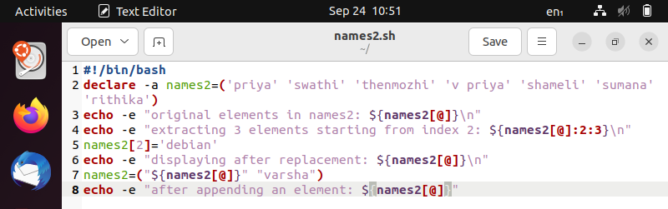
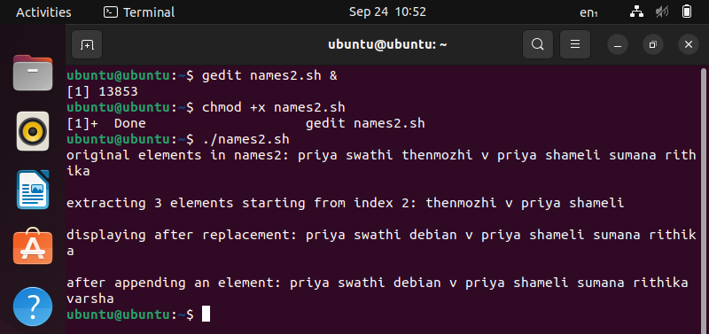

- Conditional execution
1) Write a script which will take your name as an input.
2) It should check this name with your system's username.
3) If the username matches, it should greet you by displaying "Hello".
4) Else, it should display "Try again"
HINT: Your system's username is stored in a variable $USER
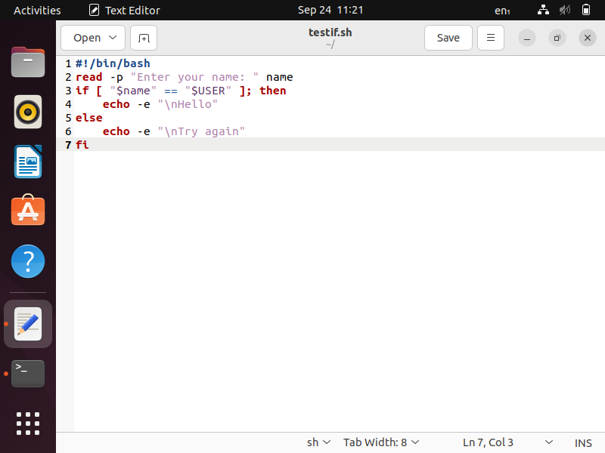
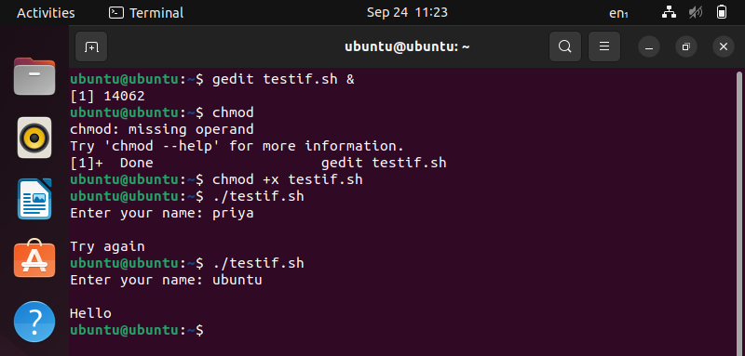
- Nested and multilevel if elseif statements
Write a program to output different messages when number is:
a. Greater than 3
b. Lesser than 3
c. Or equal to 3
d. Or when the user input is empty
